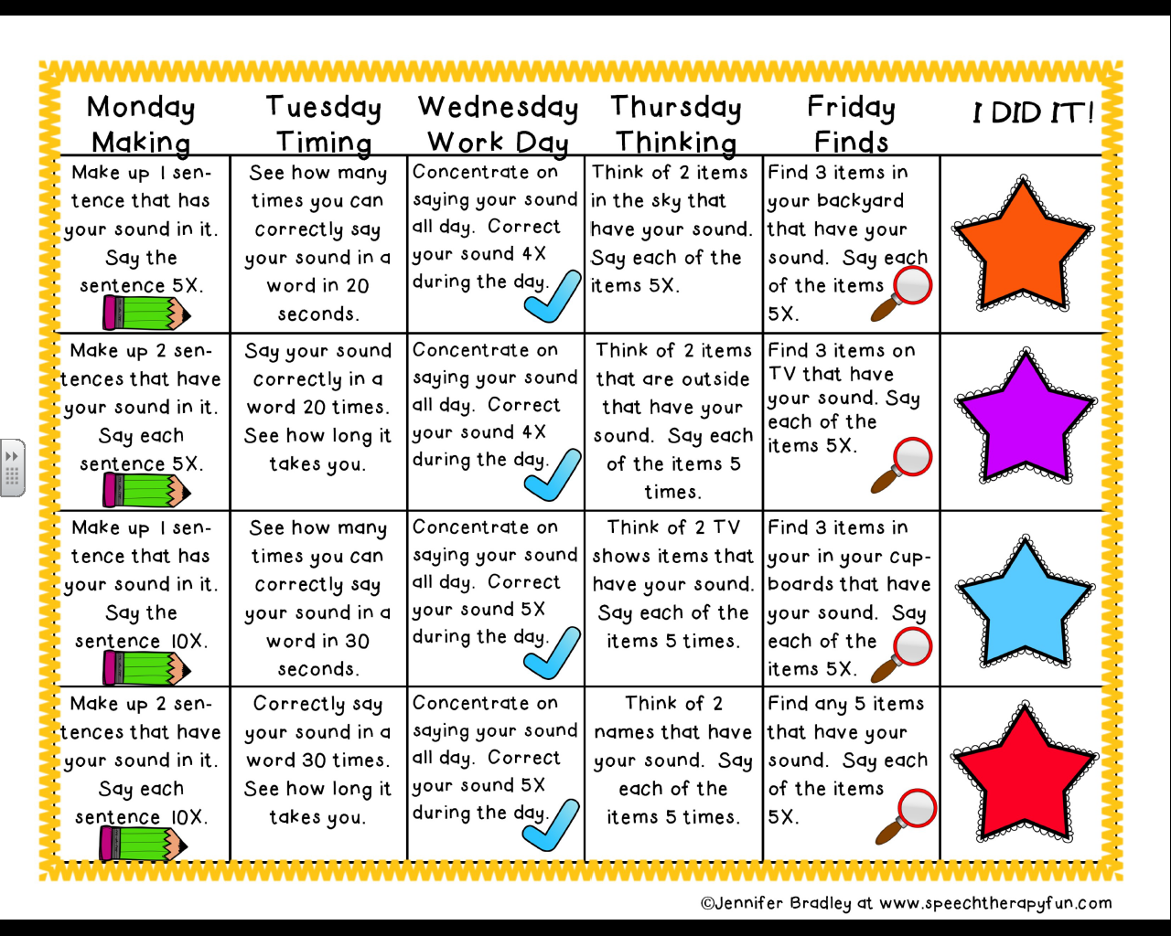

Summer Articulation Calendar

(To be used with any sound)